Eagle Scout Challenge

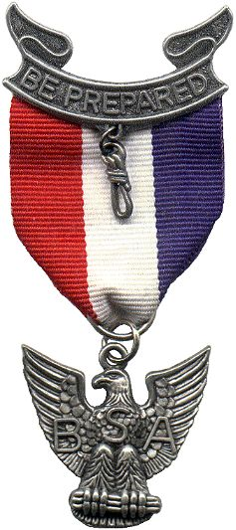
The foremost responsibility of an Eagle Scout is to live with honor. To an Eagle Scout, honor is the foundation of all character. He knows that "A Scout is trustworthy" is the very first point of the Scout Law for a good reason. An Eagle Scout lives honorably, not only because honor is important to him but because of the vital significance of the example he sets for other Scouts. Living honorably reflects credit on his home, his church, his troop, and his community. May the white of the Eagle badge remind you to always live with honor.
The second obligation of an Eagle Scout is loyalty. A Scout is true to his family, Scout leaders, friends, school, and nation. His loyalty to his troop and brother Scouts makes him pitch in and carry his share of the load. All of these help to build the loyalty which means devotion to community, to country, to one's own ideals, and to God. Let the blue of the Eagle badge always inspire your loyalty.
The third obligation of an Eagle Scout is to be courageous. Courage has always been a quality by which men measure themselves and others. To a Scout, bravery means not only the courage to face physical danger, but the determination to stand up for the right. Trusting in God, with faith in his fellowman, he looks forward to each day, seeking his share of the world's work to do. Let the red of the Eagle badge remind you always of courage.
The fourth obligation of an Eagle Scout is to be cheerful. To remind the Eagle Scout to always wear a smile, the red, white, and blue ribbon is attached to the scroll of the Second Class Scout award, which has its ends turned up in a smile.
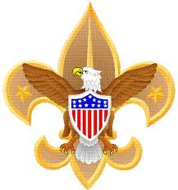
The final responsibility of an Eagle Scout is service. The Eagle Scout extends a helping hand to those who still toil up Scouting's trail, just as others helped him in his climb to the Eagle. The performance of the daily Good Turn takes on a new meaning when he enters a more adult life of continuing service to others. The Eagle stands as protector of the weak and helpless. He aids and comforts the unfortunate and the oppressed. He upholds the rights of others while defending his own. He will always "Be Prepared" to put forth his best.
You deserve much credit for having achieved Scouting's highest award. But wear your award with humility, ever mindful that the Eagle Scout is looked up to as an example. May the Scout Oath and the Scout Law be your guide for tomorrow and the future.

Eagle Scout Charge
I, ______________________ , reaffirm my allegiance to the three promises of the Scout Oath and thoughtfully recognize and take upon myself the obligations and responsibilities of the rank of Eagle Scout.
I will at all times do my best to assist other Scouts who are climbing the trail of the Eagle.
I will give back to Scouting more than it has given to me, and I will assist my Troop as much as possible.
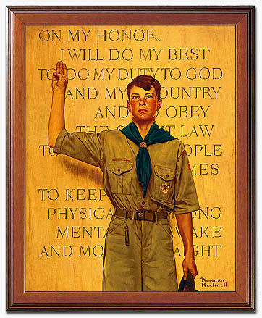
On my honor, I will do my best to make my training an example for others, to make my influence count strongly for better Scouting, in my Troop, in my community and in my family.
I pledge my sacred honor to be a living example of the Scout Oath and Law, to the best of my ability.

